Since proof of vaccinations is required to be seen here today, while you wait, please have your records e-mailed or faxed to us.
Fax: 803-667-3432 E-mail: info@spcavetcare.org
STATEMENT OF OWNERSHIP, CONSENT AND WAIVER OF LIABILITY
I hereby state that I am the owner and or agent of the above-mentioned animal, and that I am 18 years of age or older. I have the authorization to consent to treatment if and when it is needed. I hereby request the SPCA Albrecht Center to perform the above requested procedures on my animal. I agree to indemnify and hold harmless the SPCA, the attending veterinarians, and any officers or employees of said corporate entity from any and all liability arising out of the performance of all procedures referred above.

_________________________________________________________ _____________________________________
Legal Owner or Responsible Party Date:

*Services and Vaccines Needed Today

*Requested vaccines and services for DOGS
- 1yr Rabies Vaccine (Required Yearly) $15
- Dog Distemper/Parvo (Required Yearly) $20
- Kennel Cough (Bordetella) $25
- Leptospirosis (Recommend Yearly for Dogs with Outdoor Water Exposure) $25
- Heartworm Test (Required Yearly for Preventatives) $30

*Requested vaccines and services for CATS
- 1yr Rabies Vaccine (Required Yearly) $15
- Feline Distemper (Required Yearly) $20
- Feline Leukemia Vaccine (Testing Required) $25
- FELV/FIV Test $35

*Other requested vaccines and services
- Microchip $25
- Routine Ear Cleaning $25
- Nail Trim $22
- Deworming (Prices vary by Weight)
- Express Anal Glands $35

*Preventatives
- Has your pet had preventatives before? Yes/No

Dogs:
- Canine Advantage Multi (Topical Heartworm & Flea Prevention/ Price Varies by Weight) 1m____ 6m____ 12m____
- Tri-Heart (Oral Heartworm Prevention/ Price Varies by Weight) 1m____ 6m____ 12m____
- Nexguard (Oral Flea & Tick Prevention/ Price Varies by Weight) 1m____ 6m____ 12m_____
- Dog Seresto Collar $62

Cats:
- Nexguard Combo (Topical, Price Varies By Weight) 1m____ 3m___ 6m____ 12m____
- Cat Seresto Collar $62

*Proof of vaccines from a Veterinarian’s office is required. * If you do not have proof of vaccines, and your pet is well enough your pet will receive them today*

*Reason for visiting today:
- Wellness Exam (Required Yearly) $30.00
- Concern Exam $50.00
- Technician/Assistant Visit $10.00 (Boosters, Nail Trim, Etc.)
- If Concern Exam; please provide details.
_____________________________________________
_____________________________________________
_____________________________________________

*Patient Medical History:
- Has your pet been seen here before? Y/N
- Has your pet been seen at another veterinary practice?
If so please list who in case records are needed. _________________________________________________
- Has your pet ever had a vaccine reaction and/or seizure?
If “Yes” please explain: _________________________________________________
- Is your pet currently on any other medications?
If “Yes”, please list the medications and what your pet is being treated for ________________________________________
_________________________________________________
- Is your pet eating and drinking normally? Yes/No
- Is your pet having any vomiting or diarrhea? Yes/No
If “Yes” please explain: _________________________________________________
- Is your pet urinating normally? Yes/No
If “No”, please explain: _________________________________________________
- Additional information:(Tell us about your pets behavior at the Veterinarian office, food preference, rewarding methods)
_________________________________________________
_________________________________________________
_________________________________________________
____________________________________________________________
Pet’s Name: _______________________________
Cat/Dog Male/Neutered Female/Spayed
Age/Date of Birth: ___________________________
Breed/Fur color: _____________________________

Owner’s Last Name: ____________________________
Owner’s First Name: ____________________________
Authorized User: _______________________________
Address: ______________________________________
State: __________ Zip code: ______________________
Cell Phone Number: _____________________________

*** Payment is due in full at the time of discharge***WE DO NOT ACCEPT CHECKS***
This Side for Clinic Use Only:
NOT ACCEPT CHECKS
Pet’s Name: ___________________________________
Cat/Dog Male/Female Spayed/neutered
Age/ Date of Birth: ____________________________
Breed: ________________________________________
Fur Color: ______________________________________

199 Willow Run Road
Aiken, SC 29801
(803)648-6864

PHYSICAL EXAM REPORT
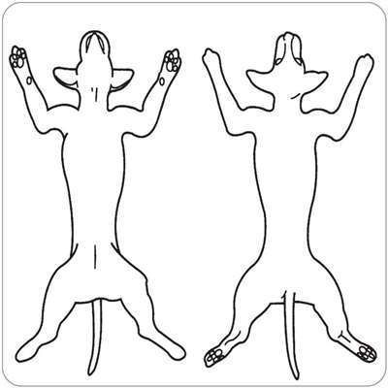
DVM: ___________________ Tech/Vet Assistant: _________________
Weight: ______________ ADDT: Yes / No

Ears/Eyes/Nose/Throat: □ Normal □ Abnormal _____________________________________
Oral: □ Normal □ Abnormal _____________________________________
Coat/Skin : □ Normal □ Abnormal _____________________________________
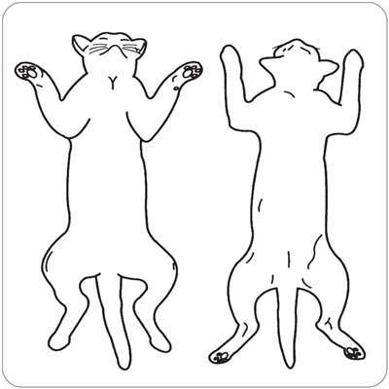
Musculoskeletal System: □ Normal □ Abnormal _____________________________________
Heart/Lungs: □ Normal □ Abnormal _____________________________________
Gastrointestinal System: □ Normal □ Abnormal _____________________________________
Uro-genital: □ Normal □ Abnormal _____________________________________
Neurological: □ Normal □ Abnormal _____________________________________
Vaccinations Preventative Care
Canine Annual Booster Feline Annual Booster Canine Feline
DHPP □ □____ FVRCP □ □____ Heartworm Test □ _____ FeLV/FIV Test □ ______
Bordetella □ FeLV □ □____ Triheart □ ______ Nexguard Combo □ ___
Rabies □ Rabies □ Advantage Multi □ ____ Seresto Collar □
Lepto □ □____ Nexgard □ _______ Revolt □ _______
Seresto Collar □ Drontal □ Strongid □
Virbantel □ Strongid □ Profender □
Additional Services: Nail Trim □ Anal Glands □ Microchip □ Ear Cleaning □
Recommendations:________________________________________________________________________________________________________________________________________________________________________________________________________________________________________________________________________________________________________________________________________________________________________________________

